STUDY GUIDE
for the
Chronicles of Narnia by C.S. Lewis

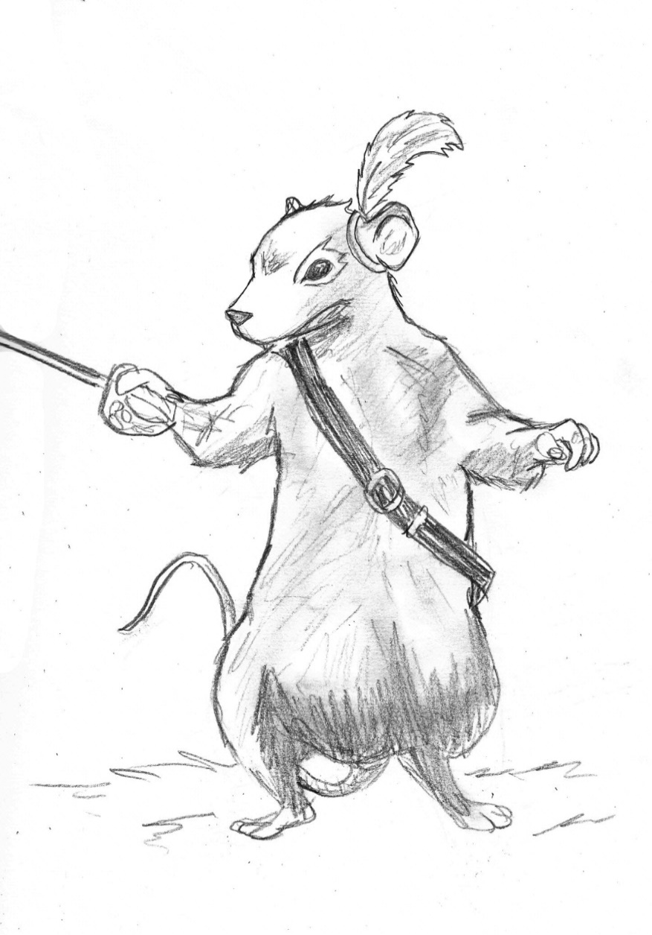

Book 2
Prince Caspian

Jeffrey L. Gerig

1 PRINCE CASPIAN pp. 1-67
1. How long have the kids been away from Narnia, in earth years? How long has it been in Narnian years? What differences are there between getting into Narnia through a wardrobe, and being drawn into Narnia off the railroad platform?

2. What is Cair Paravel an island now? What has happened to this once beautiful castle?

3. Why do you think that the four kids have been brought back? Who or what brought them back? Why do you think they were first sent to the ruins of Cair Paravel?

4. How does God at times prepare us for some great task or ministry? How important is preparation in sharing the gospel with friends, or in doing a service project?

5. Why were the gifts in the treasure room of Cair Paravel worth more than the whole kingdom itself to Peter and the others (p. 23) ?
6. Describe the ‘new’ Edmund, as compared to the old Edmund of the first book. Why is there still some of the ‘old’ Edmund, such as his temper and lack of trust in people?

7. Where has Aslan been all these years, as the Telmarines took control over Narnia? Why did he do nothing to stop the invasion? Do you think that he even knows everything that has been taking place? How do you know?

8. If God knows everything that happens to us, including the bad times and he also has the power to stop those bad times, why does He allow them into our lives?

9. What undesirable circumstances are in your life right now that you wish God would do something about? Why might they be there?

10. Who is Caspian?

11. How did Miraz come to power? What did he do to the nobles who were faithful to Caspian’s father? (p.56)

12. Describe the character of each person. Be specific:
Dr. Cornelius
Nikabrik
Trufflehunter
Trumpkin
13. Why do you think everyone has forgotten all the facts about Old Narnia? Why do even the faithful remnant have their doubts? What has happened over this time that would have made everyone forget the way things used to be? (pp. 38,39)

14. How is this forgetting the facts about Old Narnia much like how many view our Bible? Do you believe the old stories in the Bible? Which one is your favorite? Which one do you find the most difficult to believe?

2 PRINCE CASPIAN pp. 1-67
1. Notice that even the bad characters of Old Narnia still had descendants around, such as the Ogre and the Hag (p. 72). Do you think the group made the right decision not to invite them? Would Aslan really not be their friend anymore if they invited these people?

2. Nikabrik said that he would be for anyone who would batter the cursed Telmarines, even if it was the white witch herself (p. 73). He said the witch had been good to dwarfs. Why did this seem so?

3. What should be our relationship with non-believers?
a. totally withdraw from them, like they withdrew from the Ogre and the Hag?
b. work with them toward common goals, like getting rid of the Telmarines (the black dwarf’s idea)?
c. compromise our beliefs to reach the ends we desire, like Nikabrik wanted to do?

4. What is Aslan’s How? Notice that several of the remnant didn’t even know what it was (p. 85). What had they forgotten? What had become of the stone table now?
5. Again, Edmund almost loses his temper with Trumpkin (p. 98). After all that Edmund had been through, why do you think that he still carries around some of his old attitudes?

6. As Dr. Cornelius and the others discuss blowing the horn, he says there are three magical spots from where help would most likely appear (pp. 90,91). What are these spots, and why are they the most likely?
a.
b.
c.

7. When Lucy saw Aslan, nobody really believed her, but Edmund went along with her anyway (p. 123). Why did he do this?

8. Why is it so difficult to believe in things that we can’t see (pp. 123-124)? Why would the others rather follow their own judgement, than to follow the faith of Lucy?

9. According to John 20:24029, who else had difficulty believing without seeing? How did Jesus answer him?

10. Why does Aslan keep coming to Lucy first (p. 132)?

11. Aslan says the reason he appears bigger to Lucy is because she has gotten bigger (p. 136). This isn’t normal. As Lucy gets bigger, objects and people should appear smaller. Why will Aslan appear bigger as Lucy grows bigger?

12. Why does Aslan tell Lucy she may never know what would have happened, but only what will happen (p. 137)?

13. Aslan wanted Lucy to go alone if no one else would follow her. Do you think that this is a reasonable request (pp. 137-138)? Why does God sometimes make us do things alone, without the benefit of Christian support?

14. Why was it that the more they believed and followed Lucy, the more they would be able to see Aslan?

15. Describe the character of each person:
The three bulgy bears
Pattertwig
The seven brothers of Shuddering Wood (Red Dwarfs)
The five black dwarfs
Centaur Glenstorm and his three sons
Reepicheep
Wimbleweather
Nikabrik

3 PRINCE CASPIAN pp. 141-end
1. Lucy had to tell her story about Aslan four times. In what order did the group all see Aslan?

2. Susan confessed that she did believe Aslan was with them all the time, even though she couldn’t see him. What kept her from using her faith at the beginning? What was she afraid of (p. 147)? What keeps us from putting our faith into practice at times?

3. What were Aslan’s responses to the other children and the dwarf, when he met them (p. 148)?
Peter
Edmund
Susan
Trumpkin

4. Who were Bacchus and Silenus (p. 154)? Why did Susan say, ‘I wouldn’t have felt very safe with Bacchus and all his wild girls if we’d met them without Aslan?’

5. How has Nikabrik distorted the story of Aslan and the white witch (p. 162)? What did Nikabrik not know about those Olden Days?

6. Who did Nikabrik get to help them conquer the Telmarines (p. 159)? Is this the hag and the ogre that they had decided against inviting (p. 72)? Could this possibly be the white witch herself, with her captain, Feneris Wolf?

7. Why does Miraz decide to fight King Peter (p. 177)? Have you ever done something you didn’t want to, simply because you were worried how it might look to others if you didn’t do it?

8. What scared off the enemy Telmarines (p. 190)? Do you know a Bible story that is very similar to this (see 2 Samuel 5:17-25)?

9. In Aslan’s victory march, why is it primarily the women and children who are joining Aslan (p. 197)? Where are the men?

10. Aslan heals the old lady, has Bacchus turn her water into wine, and tells her that she is not yet ready for the long journey. Who is this old lady, and what long journey is Aslan talking about?

11. Why did Reepicheep get his tail back (p. 203)?

12. Where were the Telmarines from (p. 211)? How did they get into Narnia and how were most of them sent back to where they came from?

REMEMBER
1. The land of Telmar was unpeopled when they stumbled into this world.
2. A famine in Telmar is the reason they moved into Narnia and conquered it.
3. A son of Adam is always to rule over Narnia (p. 210). Why do you think this is?

Leader’s Guide
The questions in this guide are not meant to limit your group discussion, but rather to bring out new thoughts, as well as open a door of new questions for your group. Below are possible suggested answers for some of the more difficult questions in this study guide.
Study 1 Prince Caspian pp. 1 - 67
Question 1: The children have been away from Narnia one earth year, but hundreds of years have passed in Narnia. The main difference is that the first time they found Narnia, but this time Narnia found them.
Question 3: There must be some danger in Narnia which Aslan wants the human children to face. The safest and most normal place is to be brought to Cair Paravel. Aslan knew they would need the gifts from Father Christmas, and that this was where they would rescue Trumpkin. Aslan had things well planned out.
Question 8: There may be several reasons why Aslan did not intervene earlier to stop the invasion of Narnia, and several others for why bad things happen to us. If God always protected us from calamity, we would never grow in our faith, or learn dependence on Him. We would take God for granted, and become very spoiled children of God.
Question 13: What people don’t use, they lose. The people have wandered from God, and now are no longer sure He is there or that He cares. Usually in times of persecution, the word of God spreads, but in this case, everyone ran for their lives, and the fellowship of believers was broken. No one trusted anyone.
Study 2 Prince Caspian pp. 68-140
Question 1: An ogre is a monster from fairy tales that feeds on human beings. A hag is a winch or an ugly evil looking old woman. As believers, it is our duty to reach out to non-Christians and witness to them, but 2 Corinthians 6:14-18 clearly states that we are not too enter into close relationships with them. Aslan would have been very displeased if the remnant of followers would have sided with these two characters.
Question 2: Nikabrik may have thought the witch was always good to dwarfs, but that is because most of the dwarfs were on her side in the previous book.
Question 6: The three magical spots mentioned by Dr. Cornelius are 1) Cair Paravel, where the four children sat on the thrones which broke the spell of the witch. 2) Lantern Waste, where the four children first entered into Narnia. 3) Aslan’s Howe, also called the Stone Table, we’re Aslan defeated sin and the white witch, by allowing himself to be killed for the sin of everyone. These were the three spots which seemed most likely for the children to appear.
Question 11: Aslan (God) should appear bigger to us as we grow in our faith. It is our faithlessness which limits what God can do in our lives. We must be very careful not to put God in a neat little box. Rather we should make use of His mighty power.
Question 14: The reason the others could not see Aslan at first was because of their lack of faith. As they saw things working out, their faith began to grow, and they could see Aslan. We learn just who has the strong faith, as we see in what order they get a glimpse of Aslan.
Study 3 Prince Caspian pp. 141-end
Question 3: When Aslan met them, he tried to calm their fears, and put a positive construction on things. He said to Peter, “My dear son”. Peter probably was feeling like he let everyone down since he was seen as the leader, and he should have been the first to see Aslan. To Edmund, Aslan said “well done”, because of the loyalty he showed toward Lucy. Aslan expressed his forgiveness to Susan by saying, “You have listened to your fears, child. Come, let me breathe on you. Forget them.” And what else could he say to Trumpkin. He tells him, “Son of earth, shall we be friends?”
Question 4: Bacchus and Silenus were gods of mythology. Bacchus, also known as Dionysus, was a son of Zeus, but of an earthly mother, Semele. Bacchus was the god of wine. He was known for being kind and compassionate one minute and cruel the next. He often had women around him, who were wild with wine. They danced around in a frenzy. Silenus was the jolly old fat man who usually rode on a donkey, because he was too drunk to walk. He was Bacchus’ teacher, but eventually became Bacchus’ follower.
Question 5: Nikabrik had only bothered learning the story up to where the white witch has Aslan killed. This is probably because most of the dwarfs had been on her side. They didn’t dwell on what happened afterward, where Aslan rose from the dead, and defeated the witch, releasing all those who had been put under her spell.
Question 12: The Telmarines were from our world, earth. They were pirates sailing the South Seas and got lost on a deserted island, which had yet to be discovered. Six couples were chased into a cave, and stumbled into this new world. Aslan set most of them back to earth through a magical doorway.

